A000-Asia-India-Taxila-Sirsukh-Kushan-Head-Lion-Terracotta-1st century CE

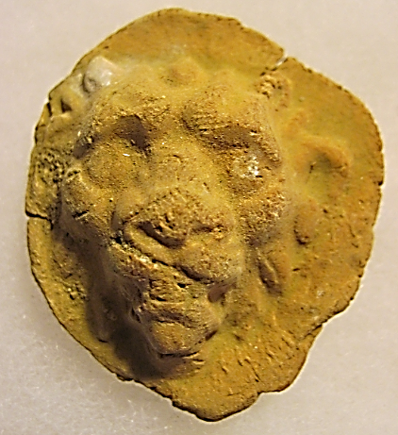

Fig. 1. India-Taxila-Sirsukh-Kushan-Head-Lion-Terracotta-1st century CE

**Case no.: 3**

**Accession Number: A000**

**Formal Label:** India-Taxila-Sirsukh-Kushan-Head-Lion-Terracotta-1st century CE

**Display Description:**

The Kushan Empire (Greek: Βασιλεία Κοσσανῶν; Bactrian: Κυϸανο, *Kushano*; Sanskrit: कुषाण राजवंश *Kuṣāṇa Rājavaṃśa*) was a syncretistic empire, formed by the Yuezhi, in the Bactrian territories in the early 1st century.

Taxila includes four major cities the last of which is of interest here as it is the location where the lion head was found. Taxila’s earliest settlement is Hathial (late 2nd millennium BCE to the 6th century BCE). The the next earliest settlement is Bhir Mound (6th century BCE). The Graeco-Bactrian Sirkap (2nd century BCE) was built following Alexander the Great's invasion in 326 BCE. The fourth settlement of Taxila is the Kushan Empire city of Sirsukh which is the location of the terracotta lion head displayed here.

The lion-leaded eagle is the symbol of Ningirsu or "Lord of Girsu," and this medallion may be a reference to his symbol.

**LC Classification:** DS392.2.T3

**Date or Time Horizon:** 1st century CE

**Geographical Area:** Taxila-Sirsukh

**Map:**

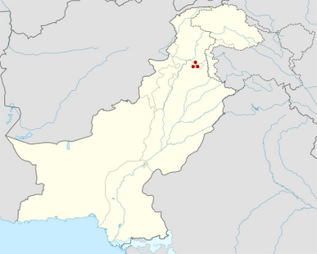

Fig. 2. Map of Taxila within Pakistan after https://upload.wikimedia.org/wikipedia/commons/thumb/6/66/Pakistan_location_map.svg/428px-Pakistan_location_map.svg.png

**GPS coordinates:** [33°46′23″N 72°50′58″E](https://tools.wmflabs.org/geohack/geohack.php?pagename=Sirsukh&params=33_46_23_N_72_50_58_E_type:landmark)

**Cultural Affiliation:** Kushan

**Media:** terracotta

**Dimensions:** H51.10 mm, 2.012 in; W 43.38 mm, 1.708 in

**Weight: 18 g, 5/8 oz**

**Condition: original**

**Provenance:** Taxila

**Discussion:**

The Yuezhi (Chinese: 月氏; pinyin: *Yuèzhī*; Wade–Giles: *Yüeh4-chih1*, [ɥê ʈʂí]) were nomadic pastoralists in western Gansu (1st millennium BCE). In the 2nd century BCE they were defeated by the ancient Mongolian Xiongnu (Dematte 2006). After this defeat the Yuezhi divided into the Greater Yuezhi (*Dà Yuèzhī* 大月氏) and Lesser Yuezhi (*Xiǎo Yuèzhī* 小月氏). The Greater Yuezhi migrated northwest into the Ili Valley where they displaced the Sakas (Scythians), but they were driven from the Ili Valley by the Wusun and then they migrated southward to Sogdia. settled in Bactria, and defeated the Greco-Bactrian Kingdom, after which they have been identified with the early Indo-European Tocharians, *Tókharioi* (Greek *Τοχάριοι*; Sanskrit *Tukhāra*) and *Asii* (or *Asioi*). During the 1st century BCE, one of the five major Greater Yuezhi tribes, the *Kushanas* (Chinese: 貴霜; pinyin: *Guishuang*), engulfed neighboring peoples to form a Kushan Empire, which, at its peak in the 3rd century CE, encompassed the territory from Turfan in the north to Pataliputra in the south. Henceforth they were instrumental in developing the Silk Road as a conduit of trade and exchange and the dissemination of Buddhism into China. Meanwhile, the Lesser Yuezhi migrated south into Tibet and Qinghai, Cumuḍa (now known as *Kumul* and Hami 哈密) in the eastern Tarim and Shanxi’s 4th Century CE Later Zhao state.

**References:**

Dematte, P. 2006, "Writing the landscape: petroglyphs of Inner Mongolia and Ningxia Province (China)." In D L Peterson; L M Popova; Adam T Smith, eds., *Beyond the steppe and the sown: proceedings of the 2002 University of Chicago Conference on Eurasian Archaeology*. Leiden, The Netherlands; Boston, Mass.: Brill, pp. 296-309.

Marshall, John. 1951. Taxila: *An illustrated account of archaeological excavations, carried out at Taxila under the orders of the Government of India between the years 1913 and 1934*. 3 vol. Cambridge: Cambridge University Press.